- Capture and analyze ARP packets using Wireshark.
Inspect the ARP request and reply frames, and discuss the role of the sender's IP and MAC address in these packets

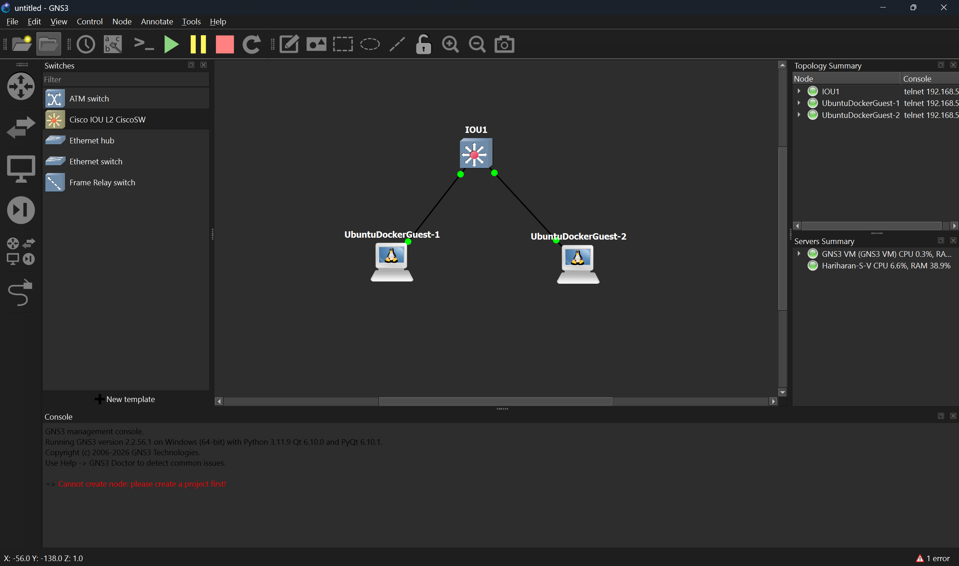
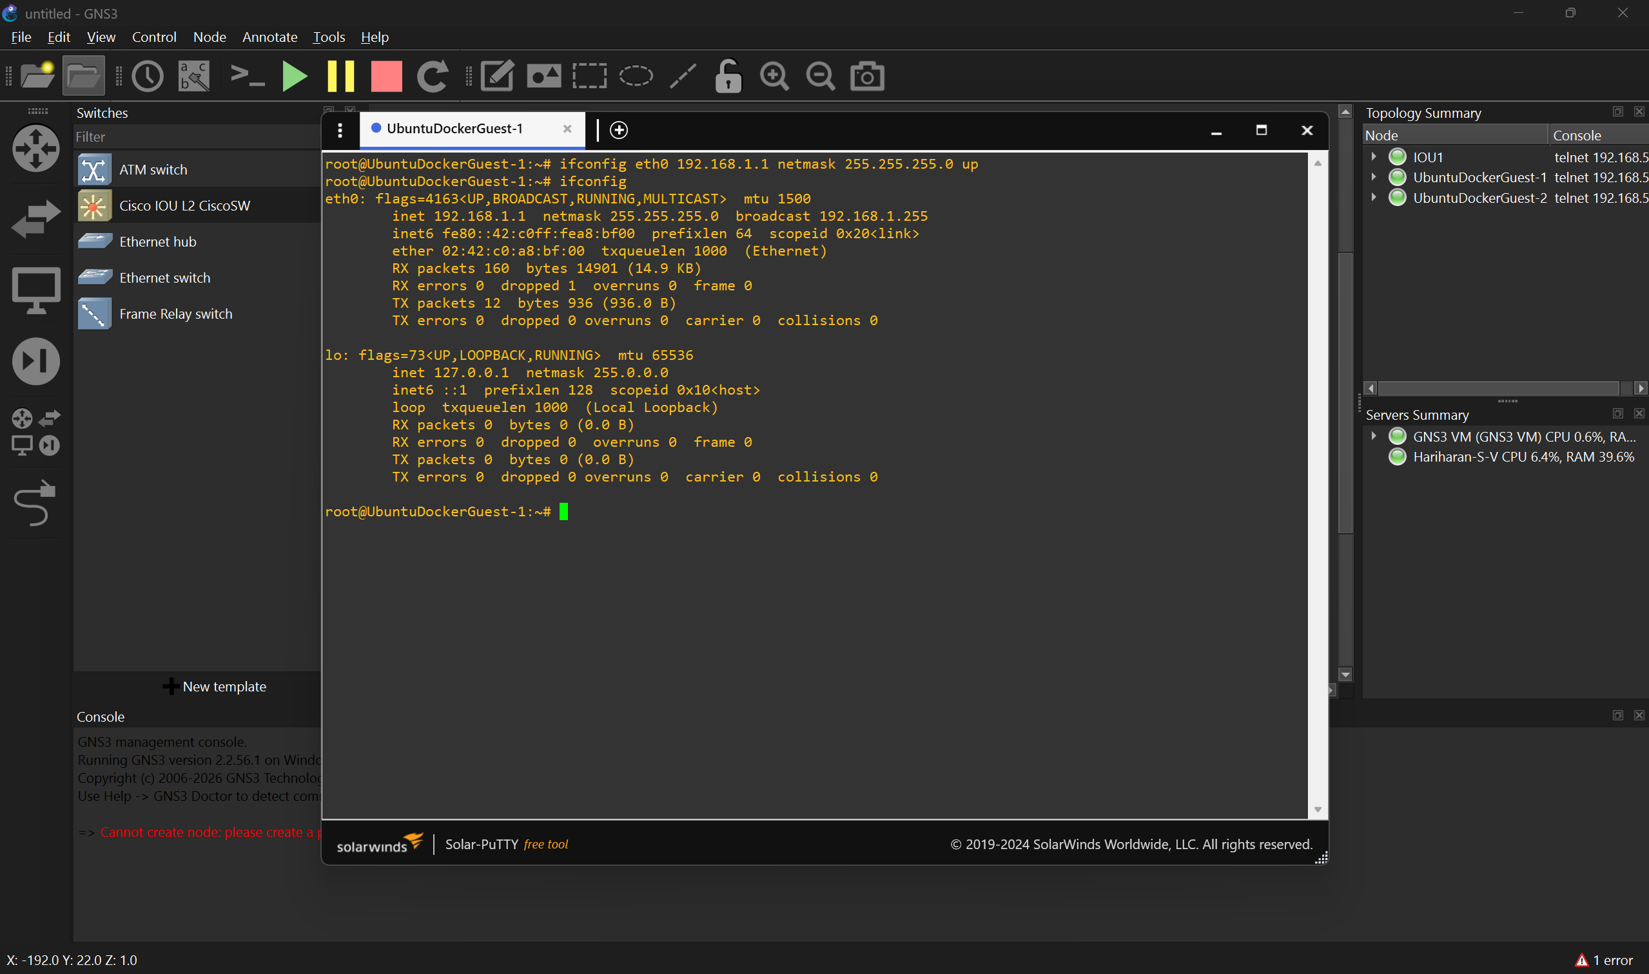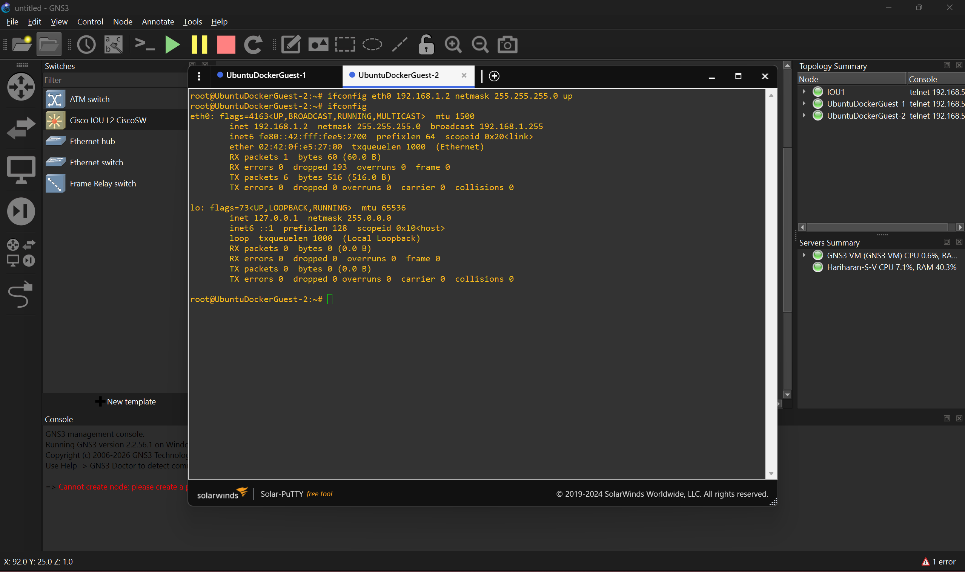
IP addresses are set for Device 1(UbuntuDockerGuest-1) and Device 2(UbuntuDockerGuest-2).
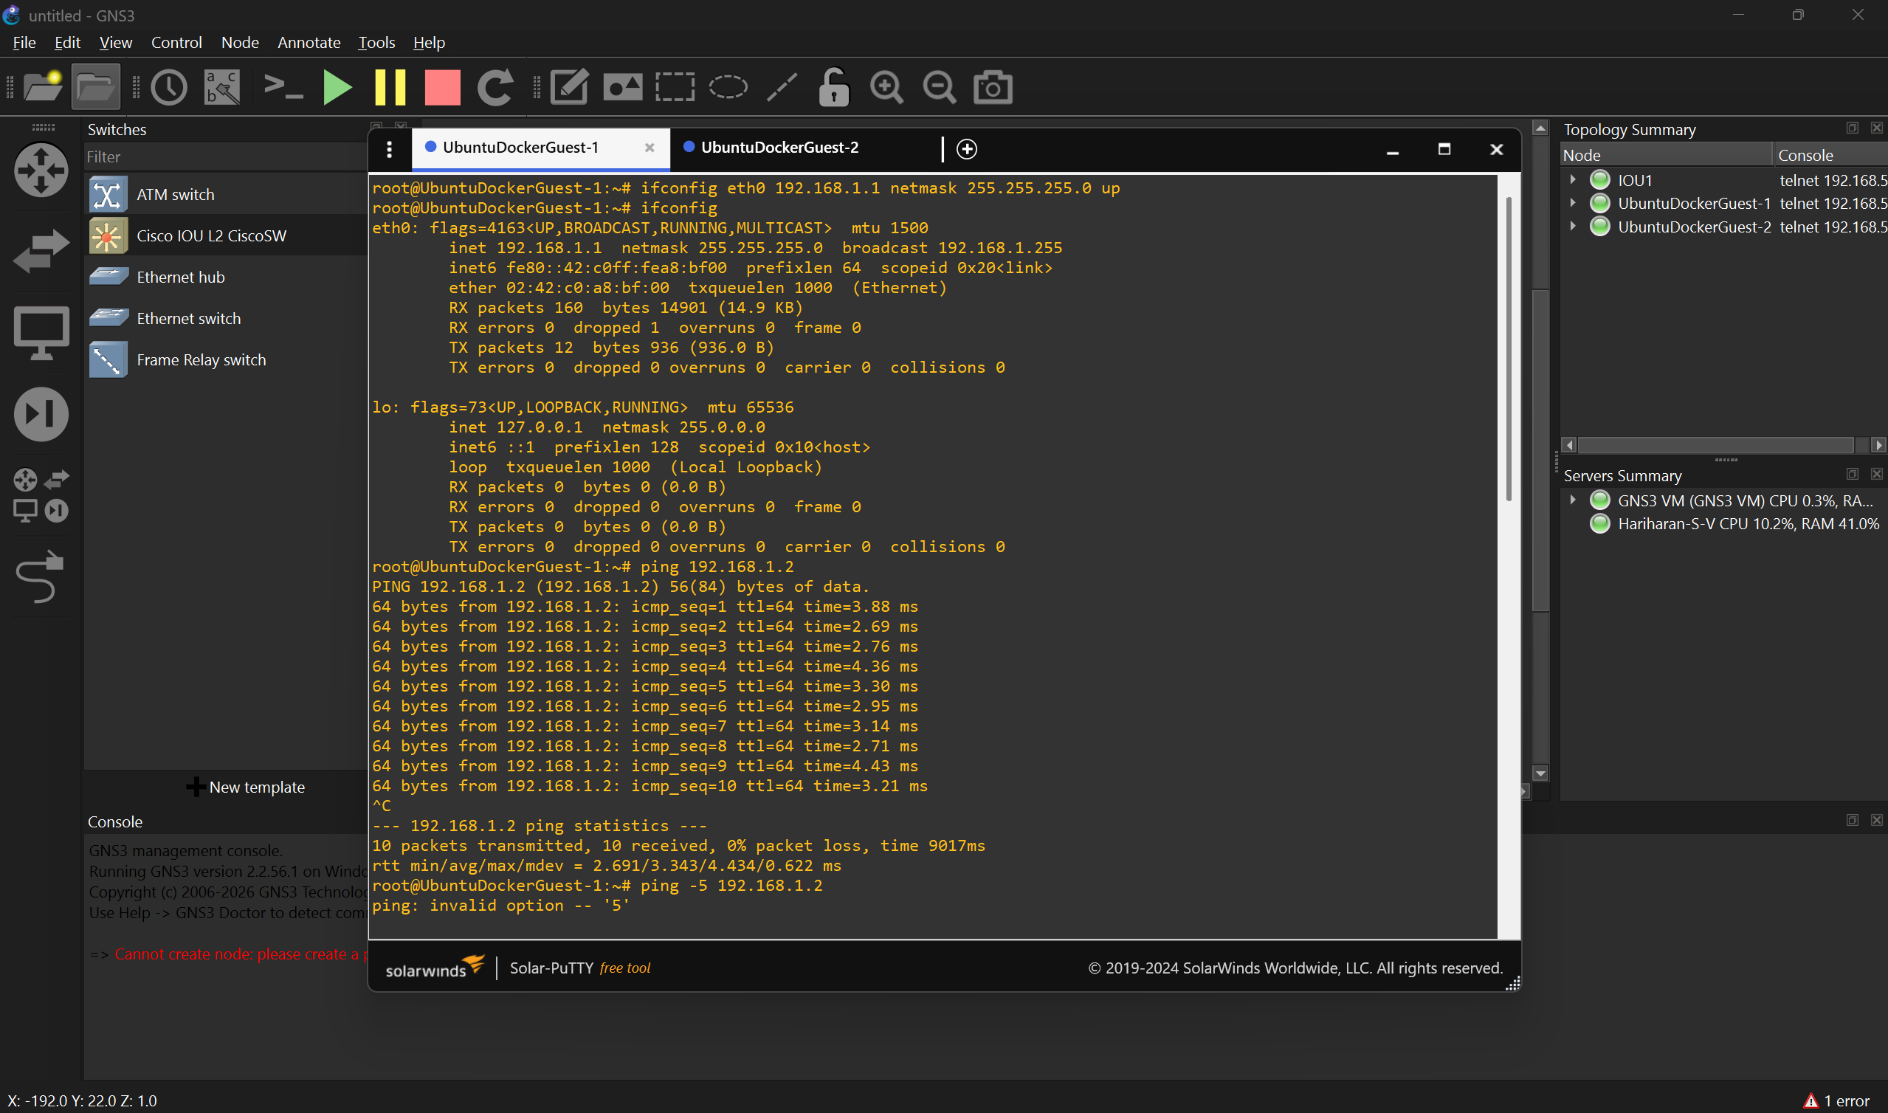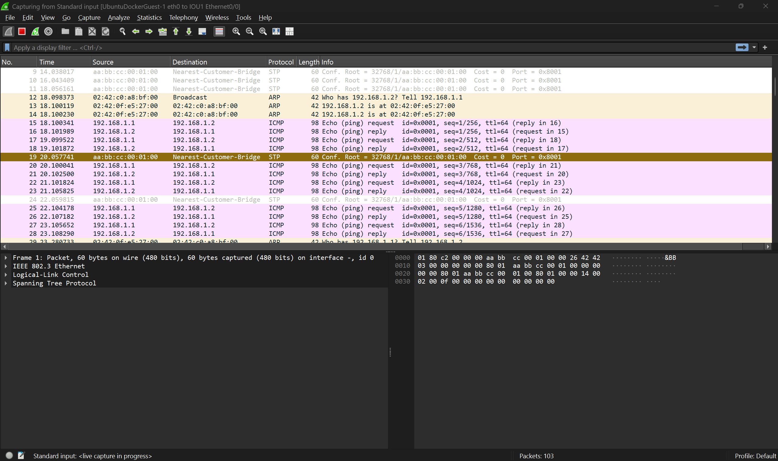
ARP request is sent by (UbuntuDockerGuest-1) (Broadcast)
ARP reply is sent by(UbuntuDockerGuest-2) (Unicast)

